Assignment: (Day-3) VLAN and Static Routing

1. VLAN Configuration
Switch(config)# vlan 10
Switch(config-vlan)# name Sales
Switch(config)# vlan 20
Switch(config-vlan)# name Support

2. Assign Ports and Verify
Switch(config)# interface range fa0/1-3
Switch(config-if-range)# switchport mode access
Switch(config-if-range)# switchport access vlan 10
Switch(config)# interface range fa0/4-5
Switch(config-if-range)# switchport mode access
Switch(config-if-range)# switchport access vlan 20
Switch# show vlan
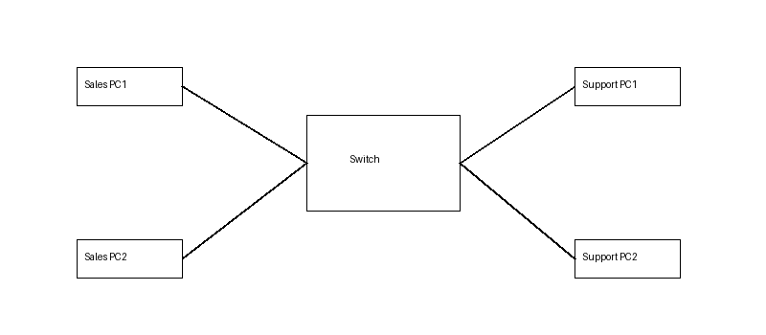

3. Static Routing
Router1:
interface g0/0
ip address 192.168.1.1 255.255.255.0
interface g0/1
ip address 10.0.0.1 255.255.255.252
ip route 192.168.2.0 255.255.255.0 10.0.0.2
Router2:
interface g0/0
ip address 192.168.2.1 255.255.255.0
interface g0/1
ip address 10.0.0.2 255.255.255.252

4. Inter-VLAN Communication
A device in the Sales VLAN cannot ping a device in the Support VLAN because VLANs are separate broadcast domains and a Layer 2 switch does not route traffic between them. Inter-VLAN communication can be enabled by configuring Router-on-a-Stick with 802.1Q trunking or by using a Layer 3 switch with routing enabled.

